Current Website: [WWW.DMHR.CO.UK](http://WWW.DMHR.CO.UK)

Requirement: Website needs to be professionally built in Zoho – with functionality for Forms new and existing, Google Analytics, Trust Pilot reviews, Side Adverts (links) optional. Employee Login option.

We must be able to change the prices as per the Rate of pay

We must be able to change the Policies at the footer easily

New contact us Page

New Request your Personal illustration Link and Page

High res images for Header slider – able to update

Website Security

SSL Certificate

Cookies tracking

Currently working on approval for the use of another websites images and information regarding additional services we provide

Compatition / Ideas links

<https://www.umbrellacompany.co.uk/our-margins.html>

<https://www.paystream.co.uk/>

<https://www.pendragonconsultancy.co.uk/>

<https://www.contractorumbrella.com/>

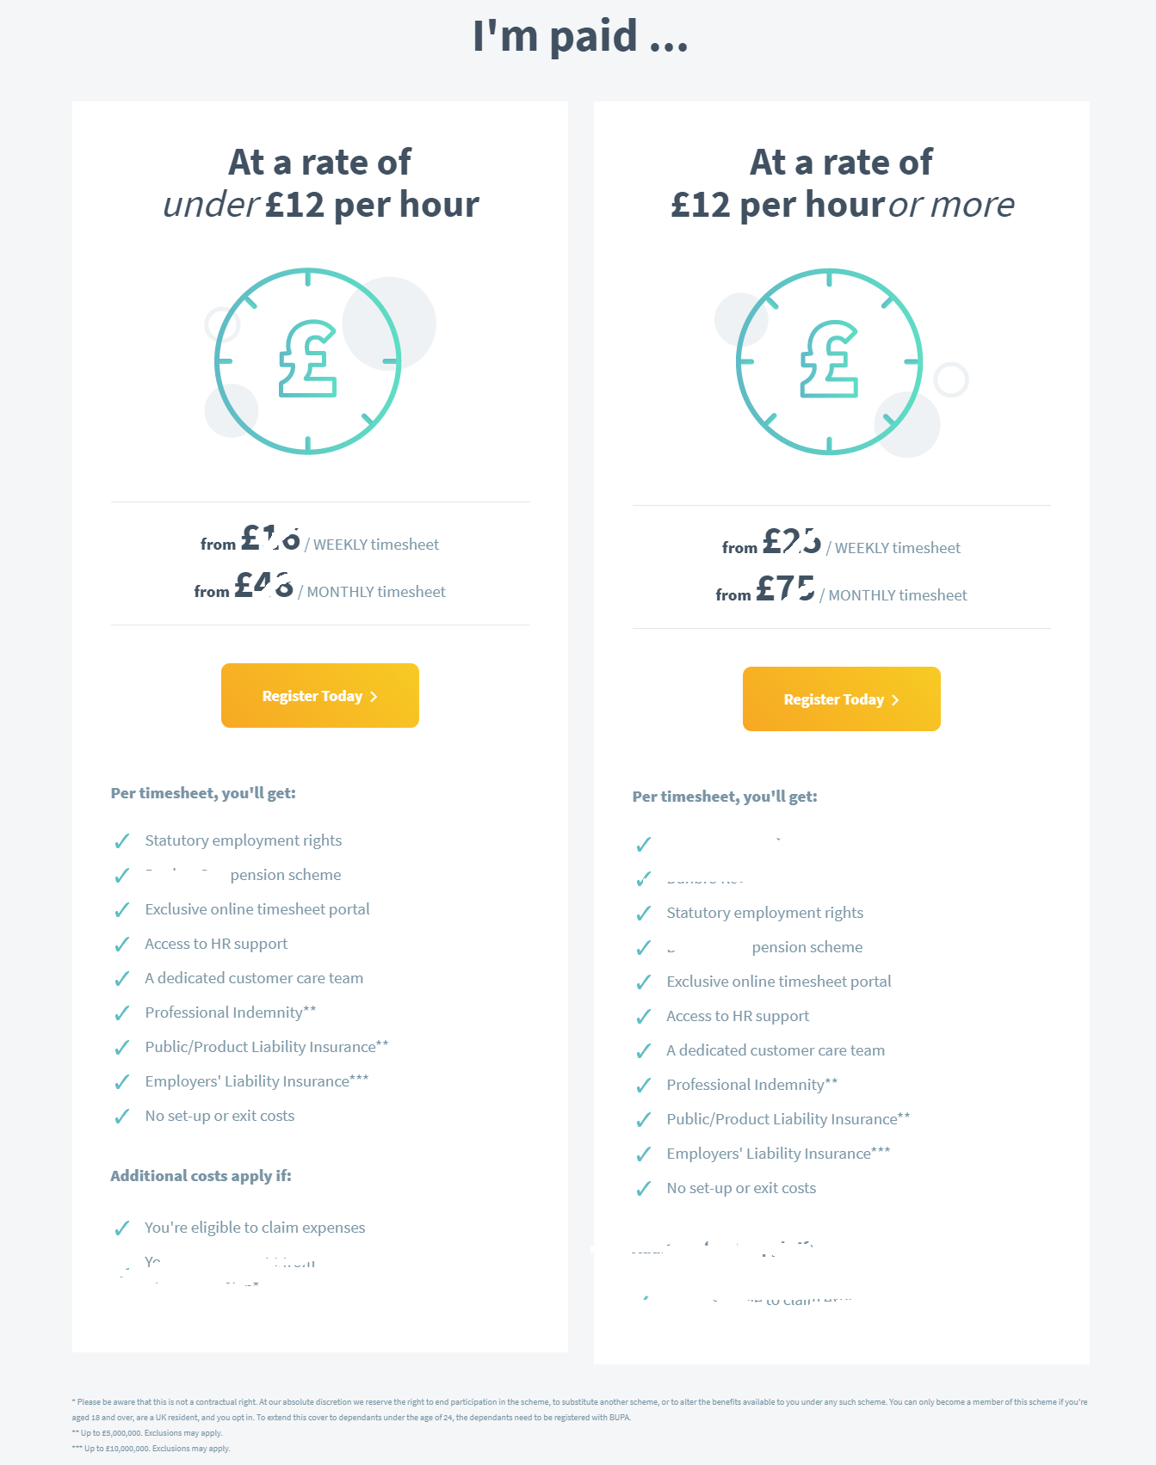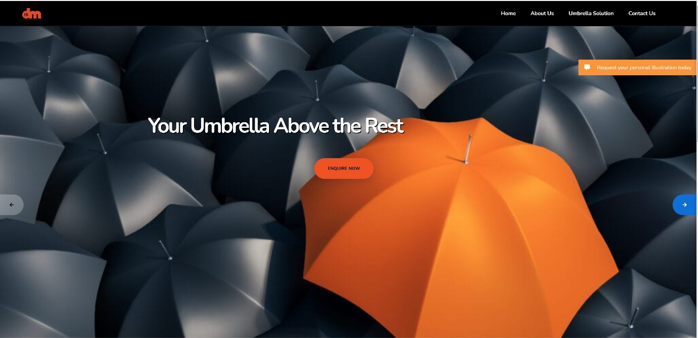

Needs re-wording